WBWBW

BWBWB

WBWBW

BWBWB

WBWBW

WBW

BWB

WBW

Output:

5

3

2

Input:

spaces.

Print a chessboard of dimensions size \* size. Print a Print W for white spaces and B for black

Output format:

The lines after that contain a different values for size of the chessboard

The first line contains the number of inputs T.

Input format:

Q) Write a program that prints a simple chessboard.

WEEK 5

2

Input:

Sample Input / Output

Print the chessboard as per the given examples

Output Format

Each test case contains an integer N and also the starting character of the chessboard

The first line contains T, the number of test cases

Write a program that takes input:

Q) Let’s print a chessboard!

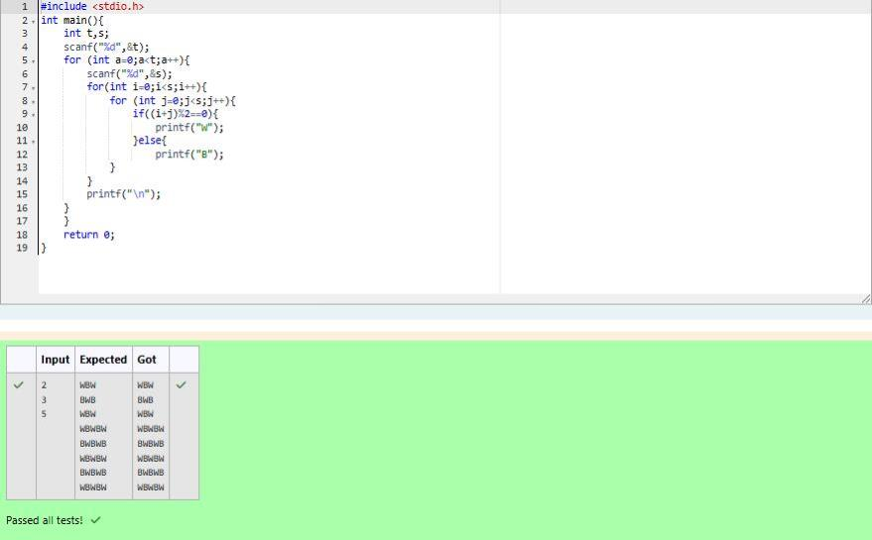

BWB

WBW

BWB

BW

WB

Output:

3 B

2 W

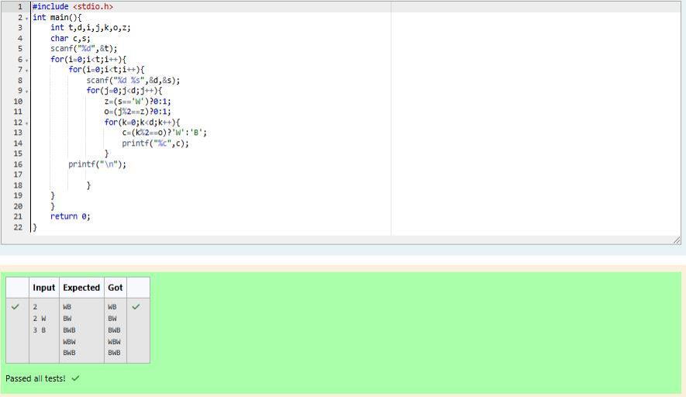

Test Case 1

In the subsequent line, print the pattern

First line print Case #i where i is the test case number

Output

Each test case contains a single integer N

First line contains T, the number of test cases

Input Format

2 <= N <= 100

Constraints

\*\*\*\*\*\*10011

\*\*\*\*809012013

\*\*50607014015016

1020304017018019020

If N= 4, then pattern will be:

\*\*\*\*607

\*\*4050809

10203010011012

then pattern will be :

If N= 3

Q) Decode the logic and print the Pattern that corresponds to given input.

\*\*\*\*\*\*\*\*15016

\*\*\*\*\*\*13014017018

\*\*\*\*10011012019020021

\*\*6070809022023024025

102030405026027028029030

Case #3

\*\*\*\*\*\*10011

\*\*\*\*809012013

\*\*50607014015016

1020304017018019020

Case #2

\*\*\*\*607

\*\*4050809

10203010011012

Case #1

Output

5

4

3

3

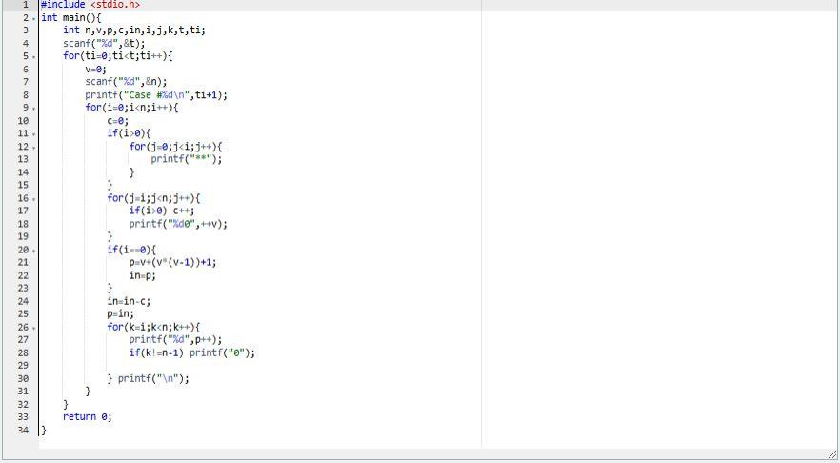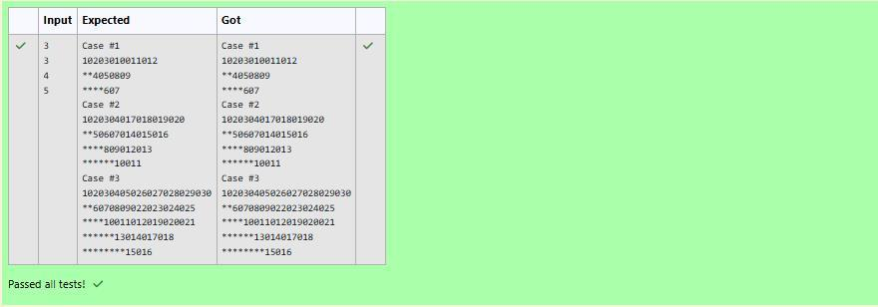

123 is a 3-digit number, and 123 != 1^3 + 2^3 + 3^3 = 36.

Explanation:

false

Output:

123

Input:

Example 2:

153 is a 3-digit number, and 153 = 1^3 + 5^3 + 3^3.

Explanation:

true

Output:

153

Input:

Example 1:

Given a positive integer N, return true if and only if it is an Armstrong number.

sums to N.

Q) The k-digit number N is an Armstrong number if and only if the k-th power of each digit

1 <= N <= 10^8

Note:

true

Output:

1634

Input:

Example 3:

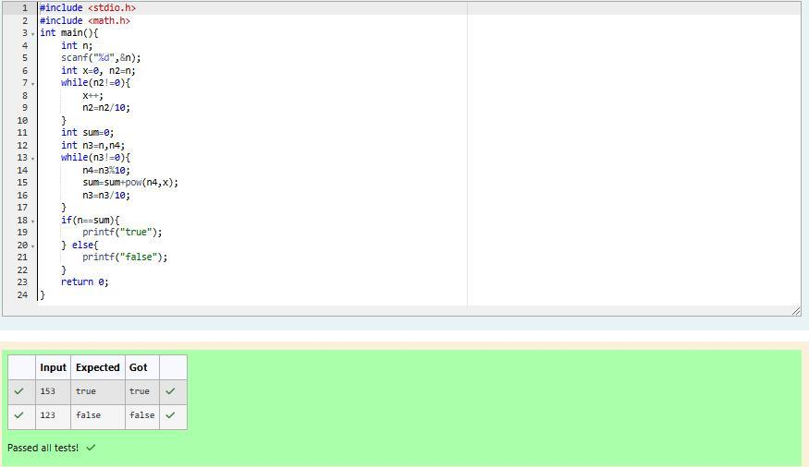

Sample Input 2 789 Sample Output 2 66066

Input 1 32 Sample Output1 55

obtained number is a palindrome. Constraints 1<=num<=99999999 Sample

Take a number, reverse it and add it to the original number until the

Q)

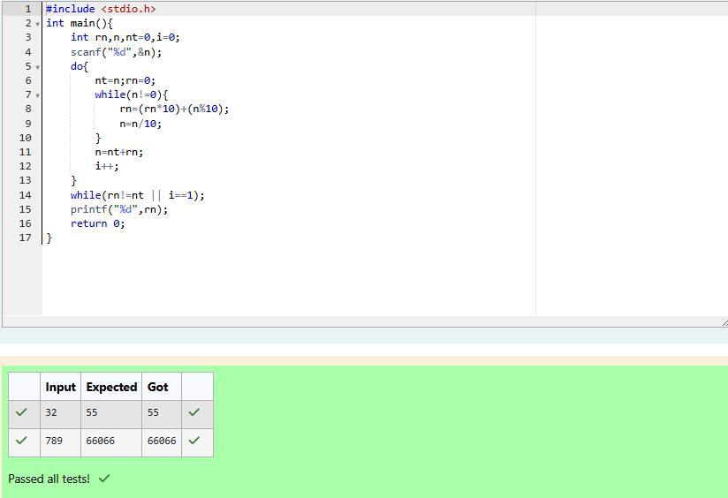

33344

Sample Output 2:

34

Sample Input 2:

Here the lucky numbers are 3, 4, 33, 34., and the 3rd lucky number is 33.

Explanation:

33

Sample Output 1:

3

Sample Input 1:

number as output.

The program should accept a number 'n' as input and display the nth lucky

have other numbers in it.

lucky number is 34 and so on. Note that 13, 40 etc., are not lucky as they

number is 3, and 2nd lucky number is 4 and 3rd lucky number is 33 and 4th

in it. Write a program to print the nth lucky number. Example, 1st lucky

Q) A number is considered lucky if it contains either 3 or 4 or 3 and 4 both

